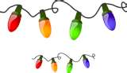

AMAZING HOLIDAY LIGHTS
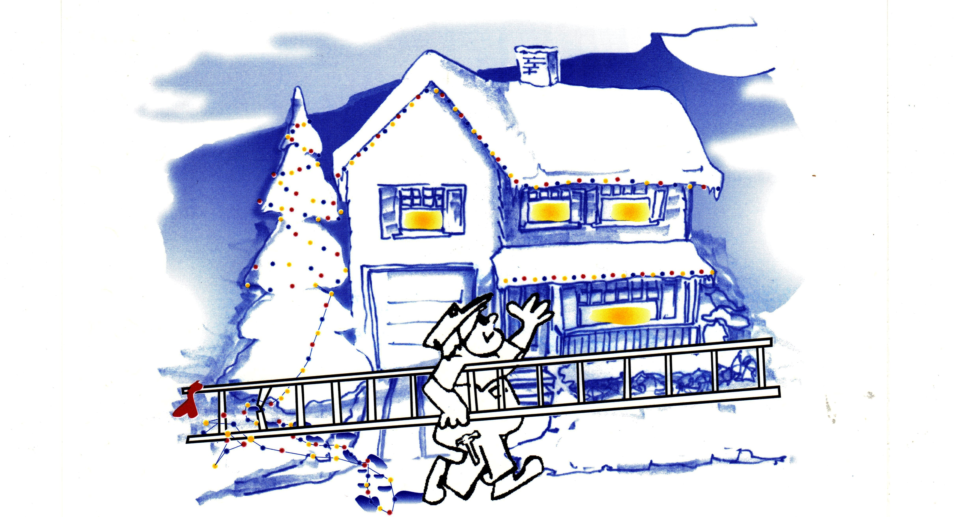

By Solid Energy, Inc.

We make it easy!!! We install and remove all your Holiday lights, including yard decorations & on foliage at a reasonable price.
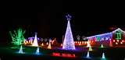
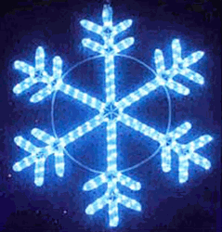
Give us a Call Today!!! 425-485-8210

